**Problem 4**

Does a football filled with helium travel farther than one filled with ordinary air? To test this, the *Columbus Dispatch* conducted a study. Two identical footballs, one filled with helium and one filled with ordinary air, were used. A casual observer was unable to detect a difference in the two footballs. A novice kicker was used to punt the footballs. A trial consisted of kicking both footballs in a random order. The kicker did not know which football (the helium-filled or the air-filled football) he was kicking. The distance of each punt was recorded. Then another trial was conducted. A total of 39 trials were run. Here are the data for the 39 trials, in yards that the footballs traveled. The difference (helium minus air) is the response variable.[**26**](javascript:ShowFootnote('20_26'))

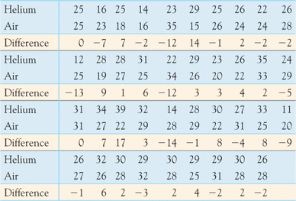

(a)Examine the data. Is it reasonable to use the *t* procedures? (10 pts)

(b)If your conclusion in part (a) is “yes,” do the data give convincing evidence that the helium-filled football travels farther than the air-filled football? (Use SAS to Test, 16 pts)

(c) Use run a randomization (Matched Pairs Test in R). (16 pts)